Hillside School SEND Report



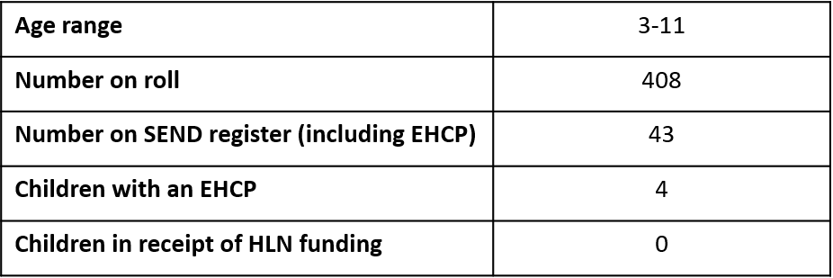
2025-2026
Our curriculum vision statement
Our school profile
Thank you for taking the time to read our information report about our special education needs and disabilities (SEND) provision within our school. The report has been written in line with the code of practice 2014
At Hillside Primary and Nursery school, our Curriculum is broad and balanced, rich, and varied, providing our children with a high-quality education and experiences that support and develop the whole child. We are committed to making every day count for all children that will not only ensure they are ready for the next stage in their education, but also prepare them for life in what will be their modern Britain.

At Hillside Primary and Nursery school, our curriculum vision is to develop our pupils’ knowledge of the world, ensure they are articulate communicators with a confident sense of the right thing to do.

Our curriculum is adapted and made accessible for all children at Hillside regardless of any SEN and Disabilities

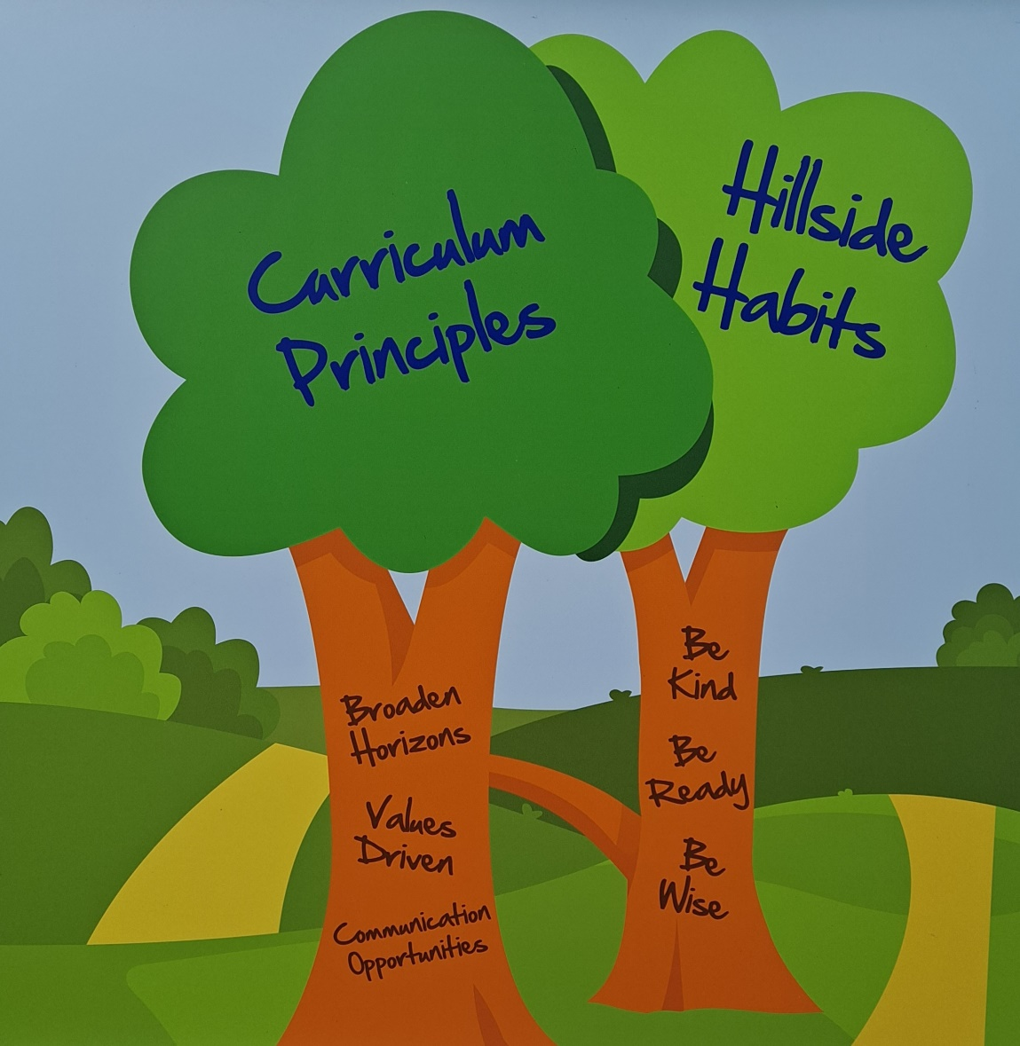

Meet the Hillside SEND Team

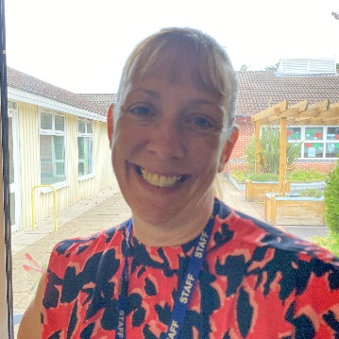
Mrs Beck is the SENCo in school. She has responsibility for coordinating the provision for all children in the school who have Special Educational Needs or disabilities. Mrs Beck is also the Attendance and Behaviour Lead.
You can contact her at senco@hillsideprimary.com

Mrs Beck is supported by a highly trained and experienced team in the day-to-day support for children with SEND.


Miss Houseman is an aspiring SENCo and is working alongside Mrs Beck, taking the lead on some areas of SEND.

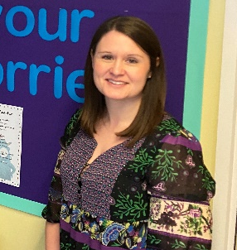

Family Support Worker
Mrs Shelton is our family support worker and ELSA (Emotional literacy support assistant)

How do we identify children with SEND?

Some children will enter school with very clearly identified needs, however for others their needs do not become fully apparent until they enter or progress through the education system.

Class teachers will make regular assessments of progress for all pupils and during this process will identify those whose progress or attainment is becoming a cause for concern. This is done through:
- Regular communication with parents/carers
- Regular communication as a staff body
- Transition meetings when a child is new to school
- Pupil progress meetings
- Data analysis
- Learning walks
- Book looks
- Pupil, staff, and parent questionnaires.

We follow the graduated approach by implementing the ‘assess plan, do, review’ approach. This involves adapting high quality first teaching strategies, planning interventions and strategies and reviewing their impact and gathering further information to create a clearer picture of the child’s needs.
Depending on the identified need, this could involve observations by the SENDCo, outside agencies, completion of checklists or formal assessments.

How do we work with parents and carers?



When a child’s progress in any aspect of their development becomes a cause for concern, we will have an early discussion with the pupil and their parents when identifying whether they need special educational provision. These conversations will make sure that:
- Everyone develops a good understanding of the pupil’s areas of strength and difficulty.
- Everyone understands the agreed outcomes for the child and what the next steps are.

We will notify parents when it is decided that a pupil will receive SEND support and parents will be invited into school to create a SEND Support Plan about their child. This will outline the support the child is receiving and will include:
- The child’s current assessments
- Their identified barriers and strategies to address these
- The pupil’s own views
- The parent’s views
- A clear outline of the provision for the pupil with clear targets and measurable outcomes.

Parents then continue to be included at every step of their child’s journey through regular (at least termly) reviews of the support in place.

What is our approach to teaching children with SEND?

Adaptations to the curriculum and learning environment
Teachers are responsible and accountable for the progress and development of all the pupils in their class and therefore high-quality teaching and learning for all pupils is our first step in responding to pupils who have SEND.

This will be adapted for individual pupils to enable them to access the curriculum alongside their peers.

We make the following adaptations to ensure all pupils’ needs are met by:
- scaffolding our daily provision to ensure that all pupils are supported to access the curriculum alongside their peers for example by giving longer processing times, pre-teaching of key vocabulary, reading instructions aloud, etc
- adapting our resources and staffing

All staff have a copy of and refer to a document entitled ‘High quality teaching for SEND’ which contains strategies to support children in the classroom under the 4 categories of need. There are also documents to support more specific adaptations in each of the individual subject areas

Additional interventions and support
Where it is identified that a child needs something additional to the adaptations made in the classroom, we also provide additional interventions:
- Read Write inc. small group sessions for phonics
- Precision Teaching
- First Class @ Number
- ELSA (Emotional Literacy Support Assistant)
- Talk Boost
- Socially Speaking
- Individual Speech and Language Therapy programmes (SaLT)

Outside agencies
With consent from parents, we also work with the following agencies to provide additional support for pupils with SEND:
- Schools and family specialist services (SFSS)
- Educational psychologists
- PSED team (social, emotional & behavioural support)
- Visual and hearing-impaired teams
- PDSS (physical disability specialist service)
- SBAP (Schools behaviour and attendance partnership)
- SaLT (speech and language therapy)
- CAMHS (Child and adolescent mental health services)
- Occupational therapy

How do we support children’s wider development and well-being?
We recognise that children’s development and progress is not only measured by academic success and therefore provide support for pupils to improve their emotional and social development in the following ways:

- we have a school council in which all children are supported to have a voice.
- ELSA’s (Emotional literacy support assistant) can provide support for those children who need more targeted emotional support.
- we have a sensory room which all children can access.
- we have a Family Support Worker who will work with the whole family to support positive outcomes for the child.
- children with SEND can access all extra-curricular activities and participation is actively encouraged.
- attendance monitoring and support through our family support worker.

We also ensure that all members of our school community are treated with tolerance and respect. This is taught as part of our jigsaw PSHE curriculum and through regular assemblies including our anti bullying assemblies.

How do we know that the support in place is working?

We evaluate the effectiveness of provision for pupils with SEND through:
- reviewing pupils’ progress towards the outcomes on their SEND Support Plans.
- holding termly reviews with parents.
- reviewing the impact of interventions on a regular basis (children are given assessments at the start and end of every intervention plus a midpoint review).
- listening to and capturing the pupils own voice and involving them in their reviews where appropriate.
- regular monitoring by the SENCO by visiting children in classes and looking at their work.

- consulting with and taking feedback from outside agencies.
- holding annual reviews for pupils with EHC plans.
- for those children who it is not possible to track progress against the usual methods, we use appropriate small step tracking systems such as BSquared or the Engagement Scale.

How do we support children who are moving between phases?
We support all our children to have smooth transitions between settings whether they are entering our setting, moving to a new class within our school or leaving us for another school.
This happens in several ways:

•During the Summer Term, transition meetings are planned to ensure detailed transfer of the child’s needs and that the SEND Support Plans are passed on to the new class teacher. Parents may be invited to attend these meetings.
• Additional transition activities may be planned for children who need it such as those with emotional needs or Autism. This may include additional visits, transition books or social stories to support them with the change involved in moving on.
• The SENDCo visits new EYFS children who have been identified prior to starting school in their Nursery or pre-school setting to plan support before the child starts with us.
• For children transitioning to a new setting (such as secondary school) we work closely with the destination school to ensure that a clear transition plan is in place.

What if I am not happy with the support being provided?

Any complaints about SEN provision in our school should be made to the SENCO in the first instance to seek a resolution.
Parents will then be referred to the school’s complaints policy on the school website if they feel that their complaint has not been addressed at this level.

Who can I contact for support?

In Nottinghamshire support for parents of children with SEND is available through ‘ask us’ (formerly known as parent partnership). They can be contacted on 0800 121 7772 or through the contact form on their website www.askusnotts.org.uk
The local authority produces their ‘local offer’ which enables parents to see the services which are available in locally for children with SEND. Nottinghamshire’s local offer is published here:
https://www.nottshelpyourself.org.uk/kb5/nottinghamshire/directory/localoffer.page?newdirectorychannel=9
Additional videos of the local offer can be accessed below:
https://youtu.be/MPNpAVrAvTc

